A

CASE STUDY ON

‘THE CAREEM 2018 DATA BREACH’
-Ethical, Privacy and Security Challenges in Artificial Intelligence and Data Science Frameworks Case Study-
It was basically an AI driven ride sharing systems.

NAME:
AYUSH ANIL BADGUJAR

MSIS ID:
M01114468

MODULE NAME:
ETHICS, PRIVACY, SECURITY, IN DATA SCIENCE AND AI

COURSE NAME:
MSC DATA SCIENCE AND ARTIFICIAL INTELLIGENCE

GUIDED BY:
DR. IKRAM UR REHMAN

Declaration of Authorship and AI Use

I confirm that this coursework is entirely my own work and that I have not plagiarized or copied material from any source.
All sources of information used have been properly acknowledged in the references section, and no part of this work has been submitted for assessment elsewhere.
I further confirm that I have not used AI tools for content generation in this coursework.
If AI tools were used, they were used responsibly and only to support minor tasks such as improving clarity or checking grammar.

TABLE OF CONTENTS
SECTION  NO. |  | DESCRIPTION | PAGE NO.
• |  | Title Page | 1
• |  | Declaration of Authorship and AI Use | 2
• |  | Table of Contents | 3
• |  | List of Figures & Tables | 4
• |  | Abstract | 5
11  1  swdw |  | Introduction and Background | 6
 | 1.1 | Objective | 8
 | 1.2 | Research Questions | 8
2 |  | Method and Evidence Base | 9
3 |  | Ethical Analysis | 10
 | 3.1 | Accountability and Delayed Disclosure | 10
 | 3.2 | Explainability and Fairness in AI Systems | 10
 | 3.3 | Stakeholder Harm | 11
11  4 |  | Privacy Analysis | 12
 | 4.1 | Data Minimisation and Purpose Limitation | 12
 | 4.2 | Consent Management | 13
 | 4.3 | Anonymisation and Storage Practices | 13
5 |  | Security Analysis | 14
 | 5.1 | Security Threats Identified | 14
 | 5.2 | Framework Application | 15
 | 5.3 | Effectiveness of Post-Breach Controls | 15
6 |  | Integrated Discussion | 17
 | 6.1 | How Ethical Failure Worsened Privacy Harm | 17
 | 6.2 | How Privacy Deficiencies Increased Security Exposure | 17
 | 6.3 | Transparency, Security and Ethical Tension | 17
7 |  | Conclusion and Reflection | 19
8 |  | Video or Recorded Presentation | 19
9 |  | References | 20

LIST OF FIGURES & TABLES
Sr.No. | Figure Name | Page No.
1 | Reconstructed architecture of Careem’s AI-driven cloud system based on threat modelling literature | 6
2 | Careem Breach attack pathway identified in the breach and the subsequent GNN-based security response | 16

Sr.No. | Table Name | Page No.
1 | Careem 2018 Data Breach Key Timeline of Events | 7
2 | Stakeholder Identification and Impact Analysis | 8
3 | Ethical Framework Application to the Careem 2018 Breach | 11
4 | GDPR Data Protection Principles and Identified Violations in the Careem Case | 13
5 | Principal trade-offs identified across the three analytical dimensions, drawing on evidence examined throughout this report. | 18

Abstract

This case study critically analyzes the ethical, privacy, and security issues raised by the 2018 Careem data breach accident, where 14 million user profiles and 5,58,000 driver records were illegally exfiltrated from the cloud-based system of the AI-powered mobility platform operating in the Middle East, North Africa, Pakistan, and Turkey. There was a delayed disclosure of this incident for about three months, the company heat on the impact of its incidence on the concerned parties. This analysis is based on peer-reviewed scholarly literature and regulations such as the General Data Protection Regulation (GDPR, 2016) and ISO/IEC 27001:2022, as well as professional codes like the ACM Code of Ethics (2018), used to study the case using the following criteria. According to evidence available from the case, the data security culture existing in Careem prior to the incident under discussion was marked by insufficient data minimization, lack of appropriate consent management mechanisms, and unethical management practices. Considering all available evidence, it can be argued that a more complete adoption of principles of Privacy by Design and AI-specific risk management approaches could have minimized both risks and consequences of the incident.

- Introduction and Background
The 2018 Careem data breach which represents one of the most important cyber security failures taken place in the Middle East, North Africa, Pakistan, and Turkey (MENA-PT) region, experiencing systemic vulnerabilities that may be considered inherent in AI-driven super-app ecosystems. Founded in Dubai in 2012, Careem is operated as a comprehensive mobility and delivery app platform, with machine learning coming across core functions including ride-hailing, route optimisation, demand forecasting, and fraud detection (Alharbi et al., 2020). The platform's important dependence on continuous user data collection which lists names, email addresses, phone numbers, and trip histories generated datasets that simultaneously powered algorithmic systems and constituted a critical point of the breach.
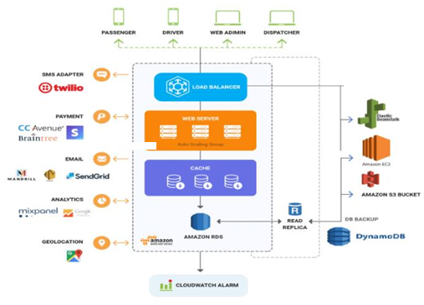
Figure 1: Reconstructed architecture of Careem’s AI-driven cloud system based on threat modelling literature.
The fraud is been noticed to have seen in December 2017, when Careem's super app cloud based server infrastructure was accessed by unauthorised actors, resulting in the managment of personal data belonging to approximately 14 million users and 5,58,000 drivers. So, the scam was not detected internally until 14 January 2018, and Data breach to media public was hold until April 2018, a delay of approximately three months. This two to three months can suggest serious concerns regarding transparency and accountability obligations under upcoming data protection standards (Ababneh et al., 2025).
The case is important for two reasons. First, data breaches in AI driven platforms have been observed to visualize harms extending beyond immediate data loss such as identity theft, financial exposure, and long term erosion of public trust in digital media services (Madnick, 2022). Second, the fraud may have exposed structural deficiencies in cybersecurity governance when MENA nations were actively positioning themselves as digital economy leaders, leading a potential gap between ambition and institutional resilience (Chandra et al., 2019).
Date | What happened? | Understanding
December 2017 | Unauthorised access to AWS cloud servers initiated | Data exfiltration begins
14 January 2018 | Breach detected internally by Careem | Detection occurs weeks after initial intrusion
January–April 2018 | Did not known to public yet | Three-month delay users uninformed of exposure
April 2018 | Breach publicly disclosed | Accountability failure GDPR 72-hour notification principle violated in spirit
2020-2021 | Graph Neural Network fraud detection deployed by AWS Neptune | Post-breach AI remediation implemented
2020 | Uber takes over Careem for $3.1 billion | Platform absorbed into global ride-hailing ecosystem
Table 1: Careem 2018 Data Breach Key Timeline of Events
Source: Author's own compilation based on Alharbi et al. (2020), Madnick (2022), AWS/Careem (2021)

Stakeholder | Role in the System | Primary Impact from Breach
Platform users (14 million) | Data subjects, ride-hailing customers | Risk of identity theft, loss of trust in digital platforms
Drivers / Captains (558,000) | Gig workers, service providers reliant on the platform | Personal data exposed, livelihood and safety risk
Careem (organisation) | Data controller, AI system operator | Reputational damage, regulatory scrutiny
UAE and regional regulators | Oversight bodies, policy enforcement agencies | Pressure to strengthen regional data protection laws
Digital economy and society | Broader public ecosystem | Reduced confidence in AI-driven super-app services
AWS (infrastructure provider) | Cloud service, storage and compute provider | Indirect accountability for cloud-level security controls
Table 2: Stakeholder Identification & Impact Analysis
Source: Author's own compilation based on Alharbi et al. (2020), Chandra et al. (2019), Madnick (2022)
1.1. Objective
Analyse the ethical, privacy, and security considerations surrounding the Careem data breach of 2018, presenting on relevant theories in artificial intelligence and data science.
1.2. Research Questions
• How did the data breach violate fundamental concepts related to data protection like data minimisation and purpose limitation, in relation to AI and data science processes at Careem?
• Which ethical problems taken in relation to personal data usage by Careem via their AI operations, such as delayed notification, accountability failures, fairness problems?
• What potential security hazards were disclosed by the data breach, and how well are advanced AI tools like graph neural networks succeeding in preventing them?

- Method and Evidence Base
Evidence and information for this report was processed using systematic searches on peer-reviewed academic databases like Google Scholar, Scopus, IEEE Xplore, SpringerLink, and ResearchGate. Google Search were typed using Boolean operators, logical connectors that combine search terms including combinations such as "Careem 2018 data breach" AND, "ride-hailing AI" AND, and "graph neural networks" AND "fraud detection" AND "mobility platforms." Searching and Filtration required sources such as peer-reviewed journal articles, conference papers from recognised publishers such as ACM, IEEE, statutory and regulatory texts, or reports from professional bodies. Sources were excluded peer-review status could not be confirmed, where claims were unverifiable, and total 22 sources were read, of which 18 sources were selected as directly relevant based.
The analytical frameworks applied throughout this report include the ACM Code of Ethics and Professional Conduct (2018) for ethical evaluation, the General Data Protection Regulation (GDPR, 2016) and ISO/IEC 27001:2022 for privacy and security assessment, and the NIST AI Risk Management Framework (2024) for evaluating AI-specific risks. The AI4 People ethical framework studies (Floridi et al., 2018) and mainly Privacy by Design principles (Cavoukian, 2009) can provide additional information lenses practices are examined and studied in the sections that follow.

- Ethical Analysis
The 2018 Careem data breach raised different difficulties such as accountability, fairness, explainability, and stakeholder harm in AI-driven data science systems. Noticing main worry is that these problems did not arise from the breach itself, but from organisational decisions planned before and after it particularly the three-month delay in public disclosure and the absence of ethical governance mechanisms within Careem's AI frameworks. This section experiment these problems with two complementary frameworks: the ACM Code of Ethics and Professional Conduct (2018) and the AI4People ethical framework given by Floridi et al. (2018), which finds five principles for responsible AI beneficence, non-maleficence, autonomy, justice, and explicability.
  - Accountability and Delayed Disclosure
The most important ethics failure studied in the Careem case is the late disclosure of the breach to affected users. Personal data of approximately 14 million users and 558,000 drivers was extracted as early as December 2017, but fraud news to public was hold until April 2018 a period of approximately three months. The ACM Code of Ethics (2018, Principle 1.3) requires data professionals and to disclose information that may cause harm if withheld. It may be argued that Careem's delayed disclosure presented a direct violation of this principle, as users were denied the opportunity to take protective measures for example: changing passwords. Evidence from Doerfler et al. (2024) further indicates that delayed breach notifications in digital platforms heavily reduce user’s ability to respond clearly, thereby compounding the harm caused by the initial invasion. Furthermore, Ababneh et al. (2025) said that organisations operating AI systems carry an ethical duty to figure out transparency in all stages of system failure.
  - Explainability and Fairness in AI Systems
Explainability constitutes an additional area of ethical concern. Careem's users had no visible means of understanding how their personal data contributed to algorithmic decision-making processes such as dynamic pricing or driver allocation. The absence of explainability mechanisms may be considered a violation of the AI4People principle of explicability, which holds that AI systems ought to be understandable to those they affect (Floridi et al., 2018). The ACM Code of Ethics (2018, Principle 1.4) similarly requires that systems be designed to protect users' right to understand decisions made about them.

  - Stakeholder Harm
Users faced risks of identity theft and targeted fraud, whilst many drivers who depended on the platform as a primary source of income faced additional exposure of location and personal identity data.
At an organisational level, evidence mark that data breaches of this scale cause measurable and reputation damage, reducing user confidence and long-term platform vision (Kamiya et al., 2021). At a societal level, the breach contributed to decreasing public trust in AI-driven super-apps across the MENA region, a market in which digital adoption was increasing rapidly at the time (Chandra et al., 2019). It may be argued that the total harm caused to over 14 million individuals substantially outweighed any operational benefit derived from Careem's data collection practices, particularly given that enhanced privacy protections could have been implemented without materially compromising system performance.
Ethical Principle | Framework | Application to Careem
Honesty and accountability | ACM Code (Principle 1.3) | Three-month disclosure delay withheld critical information from affected users
Non-maleficence | AI4People (Floridi et al., 2018) | Delayed disclosure increased user exposure to identity theft and fraud
Justice and fairness | AI4People (Floridi et al., 2018) | Compromised training data may have produced biased AI outputs affecting user groups unequally
Explicability | AI4People (Floridi et al., 2018) | No mechanism to understand how personal data was used in AI decision-making
User rights and transparency | ACM Code (Principle 1.4) | Algorithmic systems lacked explainability tools
Table 3: Ethical Framework Application to the Careem 2018 Breach
Source: Author's own compilation based on Floridi et al. (2018), ACM (2018), Ababneh et al. (2025)
To conclude that the ethics failures of Careem breach suggest that the integration of AI and data science frameworks within mobility platforms requires governance structures that extend beyond technical compliance. Accountability, fairness, and explainability must be studied as operational requirements if public trust in AI-driven platforms is to be maintained.

- Privacy Analysis
The 2018 Careem data breach exposed a substantial volume of highly sensitive personal data, the collection and retention of which was central to the platform's AI-driven operations. The dataset included full names, email addresses, phone numbers, and detailed trip histories of precise pickup and drop-off locations of 14 million users and 558,000 drivers. Sensitive trip history data may be considered, including home and workplace locations, religious sites frequented, and health-related travel behaviour, especially when mixed with other personal identifiers (Cottrill, 2020). This section evaluates Careem's privacy practices against the data protection principles established under the General Data Protection Regulation (GDPR, 2016) and the technical standards set in ISO/IEC 27001:2022, although acknowledging the complexity of applying European regulatory frameworks to a platform operating specifically in MENA region.
  - Data Minimisation and Purpose Limitation
The main concern to consider is whether Careem's data collection practices were proportionate to the operational purposes for which data was collected. However, it may be countered that ride-hailing platforms require historical trip data to optimise service delivery and that some degree of secondary use is inherent to AI-driven systems.
Evidence suggests that complete trip histories were retained indefinitely within Careem's systems, extending well beyond the immediate transactional purpose of completing a ride (Aslam et al., 2022). Furthermore, GDPR Article 5(1)(b) requires that data be collected for legitimate purposes, the principle of purpose limitation. The use of location data to train machine learning models for demand forecasting and dynamic pricing may be taken an extension of purpose beyond what users could reasonably have anticipated at the point of data collection (Nie et al., 2024). However, it may be countered that ride-hailing platforms require historical trip data to perform some improvements in service delivery and that some degree of secondary use is inherent to AI-driven systems. Whilst this argument carries operational merit, it does not appear to satisfy the GDPR requirement for explicit user consent to secondary data processing purposes (Nie et al., 2024).

  - Consent Management
Consent was obtained through broad, generalised terms of service agreements rather than by specific mechanisms. Evidence marks that meaningful consent in ride-hailing platforms requires users to be provided with clear control over how their data is gathered and used within the algorithmic systems (Nie et al., 2024). Karunakaran et al. (2018) further suggest that users consistently expect to be informed of specific data uses and retain the right to limit processing expectations that blanket consent mechanisms are unlikely to satisfy. What this suggests is that Careem's consent practices may have fallen below the standard required for informed and unambiguous consent as specified under GDPR Article 7.
  - Anonymisation and Storage Practices
Trip and location data were stored in identifiable form rather than being pseudonymised or anonymised prior to storage. This is important because, as Cottrill (2020) notes, location data in mobility platforms loses its anonymisation value once linked to persistent user profiles. Under ISO/IEC 27001:2022, it require that sensitive personal data be subject to appropriate classification, cryptographic protection, and access restrictions. Evidence marks that Careem's AWS-hosted infrastructure lacked sufficient data and encryption controls at the time of the breach, leaving identifiable user records accessible to unauthorised actors (Alharbi et al., 2020). The absence of Privacy by Design principles which advocate for proactive integration of privacy protections into system architecture may have contributed directly to the scale of the exposure (Cavoukian, 2009).
GDPR Principle | Article | Requirement | Identified Violation
Purpose limitation | Art. 5(1)(b) | Data collected for specified, explicit purposes only | Trip data used for AI model training beyond stated service purposes
Data minimisation | Art. 5(1)(c) | Data limited to what is necessary for processing | Full trip histories retained indefinitely beyond operational necessity
Storage limitation | Art. 5(1)(e) | Data not retained longer than necessary | No evidence of defined data retention or deletion policies
Integrity and confidentiality | Art. 5(1)(f) | Appropriate security measures to protect personal data | Insufficient encryption and access controls on AWS infrastructure
Lawfulness and consent | Art. 7 | Consent must be freely given, specific, and informed | Broad terms of service consent did not meet granular consent requirements
Table 4: GDPR Data Protection Principles and Identified Violations in the Careem Case
Source: Author's own compilation based on GDPR (2016), Cottrill (2020), Alharbi et al. (2020), Cavoukian (2009)
In summary, Careem's privacy practices at the time of the breach decreased considerably short of the standards required for platforms processing large-scale personal data within AI-driven systems. Deficiencies in consent management, data minimisation, anonymisation, and secure storage collectively suggest that privacy was treated as a compliance consideration rather than a foundational design principle an approach that may have directly contributed to the severity of the breach and its impact on affected stakeholders.

- Security Analysis:
The 2018 Careem data breach exposed security failing across multiple layers of the platform's cloud infrastructure and AI systems. This section finds the security threats implicated in the breach which solves relevant frameworks, and assesses post-breach outcomes.
  - Security Threats Identified
Threat modelling conducted on Careem's system architecture observed several structural vulnerabilities that may have facilitated the breach, including insufficient access controls, weak network segmentation, and inadequate encryption of data within AWS cloud infrastructure (Alharbi et al., 2020). These vulnerabilities suggest that unauthorised actors were able to traverse system boundaries without triggering detection mechanisms a finding consistent with broader evidence that cloud-hosted platforms handling large volumes of personal data face elevated exposure to credential-based intrusion and lateral movement attacks (Biener et al., 2022). Figure 1 below illustrates the probable attack pathway and the post-breach security response implemented by Careem.
Beyond conventional data breaches, AI-driven mobility platforms may also be affected to adversarial attacks targeting machine learning models directly. Lei and Ukkusuri (2025) demonstrate that malicious actors controlling multiple accounts can submit crafted fraudulent booking requests capable of disrupting AI-driven fleet management algorithms an attack vector that Careem's pre-breach security architecture did not appear to account for. This is important because it suggests that security risks in AI systems extend beyond data protection into the integrity of algorithmic decision-making itself.

  - Framework Application
ISO/IEC 27001:2022 requires organisations to introduce a formal Information Security Management System (ISMS) which gives risk assessment, access control, cryptographic protection, and incident response procedures. Annex A.8.2 of the standard gives perfect classification and handling of information assets, whilst Annex A.10.1 requires that cryptographic controls be applied to sensitive data. The available evidence says that Careem's infrastructure did not fully satisfy these requirements at the time of the breach, as user and trip data were stored without sufficient encryption (Alharbi et al., 2020). The NIST AI RMF (2024) further observes that AI systems introduce distinct risk categories such as data poisoning, model inversion, and adversarial manipulation that require governance measures
  - Effectiveness of Post-Breach Controls
Following the breach, Careem introduced a graph neural network (GNN) based fraud detection system in partnership with Amazon Web Services, utilising Amazon Neptune as the underlying graph database infrastructure (AWS/Careem, 2021). Graph neural networks features relationships between users, accounts, and transactions as interconnected nodes and edges, enabling the identification of fraudulent patterns such as shared device identifiers that conventional rule-based systems may fail to detect (Zhou et al., 2025). Liu et al. (2020) further demonstrate that enhanced GNN architectures are capable of detecting hidden fraudsters who deliberately complicate their activity patterns. Evidence from Careem's deployment marks that approximately 90 percent of accounts automatically flagged by the system were correctly identified as fraudulent, representing a substantial improvement over prior rule-based methods (AWS/Careem, 2021).
Homomorphic encryption may represent a further complementary control, as it permits computations to be performed on encrypted data without requiring decryption, thereby protecting sensitive inputs to AI models. Hannemann and Buchmann (2023) demonstrate that fully homomorphic encryption is technically feasible in smart mobility applications, adding approximately 100 milliseconds and negligible cost per transaction whilst preserving both privacy and model accuracy.
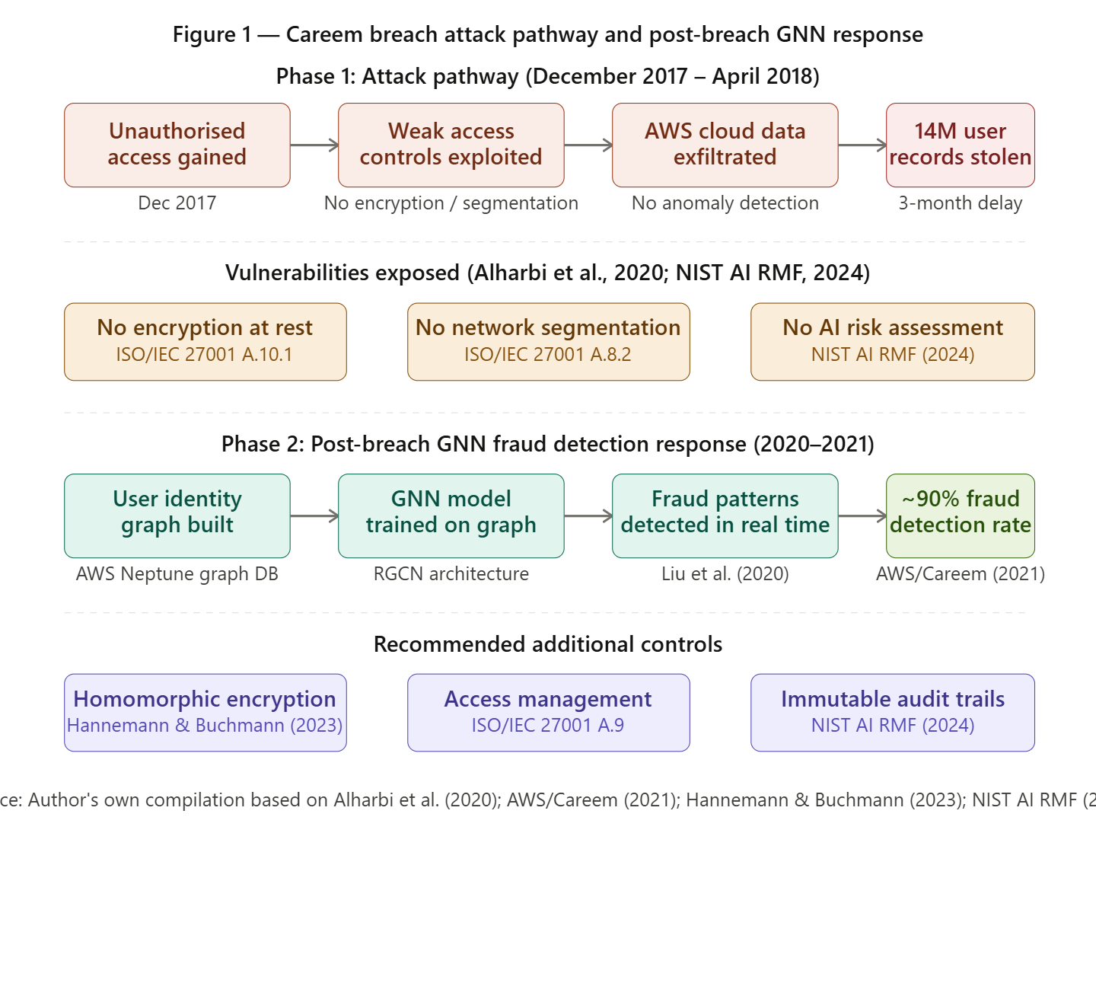
Figure 1: Careem Breach attack pathway identified in the breach and the subsequent GNN-based security response
Author's self explanation based on Alharbi et al. (2020), AWS/Careem (2021), Hannemann & Buchmann (2023), NIST AI RMF (2024)
Hence, concluding that the security failures of 2018 Careem breach suggest that conventional perimeter-based controls were insufficient to protect a platform loading large volumes of sensitive personal data within interconnected AI systems. The post-breach adoption of GNN-based fraud detection features a meaningful improvement in Careem's security posture, however, the proof indicates that proactive implementation of ISO/IEC 27001 compliant controls and AI-specific risk governance frameworks as recommended by the NIST AI RMF (2024) could have substantially reduced the likelihood and severity of the initial breach.

- Integrated Discussion
The three analytical dimensions drafted in this report ethics, privacy, and security are not independent concerns with its failures that, in the Careem case, formed a chain of downfall with broke trust. The main concern to consider is that each dimension's weakness directly boosts the effects of the others, suggesting that the breach cannot be understood in single analytical lens in isolation.
  - How Ethical Failure Worsened Privacy Harm
The three-month delay in public disclosure, mentioned in Section 3 as a violation of accountability obligations under the ACM Code of Ethics (2018), had direct effects for the privacy of affected users. During the period in which the breach remained undisclosed, approximately 14 million users were unable to take protective measures such as monitoring accounts for fraudulent activity thereby extending the window of privacy exposure beyond the breach event itself. Evidence indicates that the scale of harm resulting from a data breach is importantly influenced by the timeliness of notification, as delayed disclosure reduces customers capacity to mitigate downstream risks (Karunakaran et al., 2018).
  - How Privacy Deficiencies Increased Security Exposure
Moving on to the relationship between privacy and security, the excessive retention of identifiable trip data identified in Section 4 as a violation of GDPR data minimisation principles simultaneously increased the volume of sensitive data available to unauthorised actors at the point of breach. Had data minimisation and anonymisation practices been implemented in accordance with Privacy by Design principles, the impact of the intrusion may have been substantially reduced, as the compromised dataset would have contained less identifiable and therefore less exploitable information (Cavoukian, 2009). This relationship illustrates a critical trade-off: platforms that collect and retain large volumes of personal data to enhance AI model performance inherently increase their security exposure, as greater data availability creates greater potential harm in the event of unauthorised access (Aslam et al., 2022).
  - Transparency, Security and Ethical Tension
A further deal of message concerns the tension between transparency and security. Floridi et al. (2018) argue that AI systems thought to be explainable and transparent to those they affect, however, full disclosure of system architecture and model behaviour may expose operational effects to potential adversaries (Floridi et al., 2018). In the Careem context, greater clarity of data processing practices may have improved user trust.

Trade-off | Dimension 1 | Dimension 2 | Evidence
Data utility vs. privacy protection | Security: more data improves AI model performance | Privacy : greater data retention increases breach exposure | Aslam et al. (2022), Cavoukian (2009)
Transparency vs. system security | Ethics: explainability builds user trust | Security: disclosing system internals may expose effects | Floridi et al. (2018)
Disclosure speed vs. investigative integrity | Ethics: timely notification reduces user harm | Security: disclosure may alert attackers | Opderbeck (2019), Karunakaran et al. (2018)
Privacy by Design vs. operational efficiency | Privacy: proactive data minimisation reduces exposure | Operations : reduced data may limit AI model accuracy | Cavoukian (2009), Nie et al. (2024)
Table 5: principal trade-offs identified across the three analytical dimensions, drawing on evidence examined throughout this report.
Source: Author's own compilation based on Floridi et al. (2018), Aslam et al. (2022), Cavoukian (2009), Opderbeck (2019)
In conclusion, the Careem case establishes that ethical, privacy, and security considerations in AI-driven platforms are interdependent. Control frameworks lists each dimension in isolation are unlikely to prevent the compounding failure patterns seen in this case. A holistic, risk-based view in which privacy protections reduce security exposure, ethical accountability mechanisms enable timely disclosure, and security controls support may represent the most effective foundation for responsible AI practice in mobility ecosystems.

- Conclusion and Self Reflection
Working with the Careem 2018 data breach as a case study has increasingly developed understanding of the relationship between ethics, privacy, and security in AI driven data science systems. These three dimensions were understood as largely separate problems, were each governed by its individual set of frameworks and professional duties. What this case study has demonstrated is that they are fundamentally interconnected.
One of the more challenging aspects of this analysis worries the question of clarity. It had initially been assumed the greater interests regarding AI system behavior. However, the evidence tested suggests that clearness must be carefully balanced against security considerations, as disclosure of system internals may negligently expose damage to malicious actors (Floridi et al., 2018).
The concept of Privacy by Design also proved particularly instructive. Prior to this analysis, privacy had been studied primarily as a consent agreement. Cavoukian's (2009) framework challenged this assumption by explaining that privacy protections are most effective when fixed into system architecture.
In conclusion, this case study has moved understanding of responsible AI practice from a compliance oriented perspective towards a more integrated, governance centered approach one in which ethics, privacy, and security are treated as dependent design requirements.

- My Recorded Presentation Link:
You can use any one of the both links to view my recorded presentation. Video length is 4 minutes and 59 seconds. I think you will have to download the Screen App to view, or just click on the links below;
https://screenapp.io/app/v/2mh8AHsSBV
Kareem 2018 Data Breach Analysis

- References:
- Ababneh, M. et al. (2025) 'Cybersecurity ethical aspects', IEEE Access, 13, pp. 1–30.
- ACM (2018) ACM code of ethics and professional conduct. New York: Association for Computing Machinery.
- Alharbi, H.B. et al. (2020) 'Threat modeling for Careem system', International Journal of Computer Science and Network Security, 20(1), pp. 218–225.
- Aslam, M. et al. (2022) 'Getting smarter about smart cities: improving data security and privacy through compliance', Sensors, 22(23), p. 9338.
- AWS/Careem (2021) How Careem is detecting identity fraud using graph-based deep learning and Amazon Neptune. Seattle: Amazon Web Services.
- Biener, C., Eling, M. and Wirfs, J.H. (2022) 'Cyber risk and cybersecurity: a systematic review of data availability', The Geneva Papers on Risk and Insurance Issues and Practice, 47(3), pp. 698–736.
- Cavoukian, A. (2009) Privacy by design: the 7 foundational principles. Toronto: Information and Privacy Commissioner of Ontario.
- Chandra, G.R., Sharma, B.K. and Liaqat, I.A. (2019) 'UAE's strategy towards most cyber resilient nation', International Journal of Innovative Technology and Exploring Engineering, 8(12), pp. 1–8.
- Cottrill, C.D. (2020) 'Privacy in mobility as a service: challenges and opportunities', Transportation Research Part A: Policy and Practice, 131, pp. 258–270.
- Doerfler, P. et al. (2024) 'An exploratory case study on data breach journalism', Proceedings of the ACM on Human-Computer Interaction, 8(CSCW1), pp. 1–28.
- Floridi, L. et al. (2018) 'AI4People an ethical framework for a good AI society: opportunities, risks, principles, and recommendations', Minds and Machines, 28(4), pp. 689–707.
- GDPR (2016) General Data Protection Regulation: Regulation (EU) 2016/679 of the European Parliament and of the Council. Brussels: Official Journal of the European Union.
- Hannemann, A. and Buchmann, J. (2023) 'Fully homomorphic encryption for privacy-preserving smart mobility applications', Proceedings of the 18th Conference on Computer Science and Intelligence Systems (FedCSIS 2023), pp. 1–10.
- International Organization for Standardization (2022) ISO/IEC 27001:2022 information security, cybersecurity and privacy protection: information security management systems requirements. Geneva: ISO.
- Kamiya, S. et al. (2021) 'Do data breaches damage reputation? Evidence from 45 companies between 2002 and 2018', Journal of Cybersecurity, 7(1), tyab021, pp. 1–15.
- Karunakaran, S. et al. (2018) 'Data breaches: user comprehension, expectations, and concerns with handling exposed data', in Proceedings of the Fourteenth Symposium on Usable Privacy and Security (SOUPS 2018). Baltimore: USENIX Association, pp. 245–261. Available at:
- Lei, Z. and Ukkusuri, S.V. (2025) 'Assessing the risks of adversarial booking attack to autonomous mobility-on-demand services', Transportation Research Part C: Emerging Technologies, 178, p. 105218.
- Liu, Y. et al. (2020) 'Enhancing graph neural network-based fraud detectors against camouflaged fraudsters', in Proceedings of the 29th ACM International Conference on Information and Knowledge Management (CIKM 2020). New York: ACM, pp. 315–324.
- Madnick, S. (2022) The rising threat to consumer data in the cloud: white paper on data breaches and the security of consumer data on corporate systems, servers, and networks. Cambridge, MA: MIT Sloan School of Management.
- National Institute of Standards and Technology (2024) Artificial intelligence risk management framework (AI RMF 1.0). Gaithersburg, MD: NIST.
- Nie, F. et al. (2024) 'Impact of privacy regulation involving information collection on the ride-hailing market', Omega, 126, p. 103077.
- Opderbeck, D.W. (2019) 'Cybersecurity and data breach harms: theory and reality', Journal of Internet Law, 22(10), pp. 1–18.
- Tigga, S.L. et al. (2025) 'A comparative study of fraud detection algorithms in food delivery systems', AIP Conference Proceedings, 3208(1), p. 020045.
- Zhou, J. et al. (2025) 'Graph neural networks for financial fraud detection: a review', Frontiers of Computer Science, 19, p. 199609.

